AGENDA - Little Hoole Parish Council  Members of the Council are summoned to the Parish Council Meeting to be held on  Mon 9th March 2026 at 7pm  The Lounge, Walmer Bridge Village Hall, Gill Lane, Walmer Bridge, PR4 5GN  Paul Cafferkey, Clerk & Responsible Financial Officer | 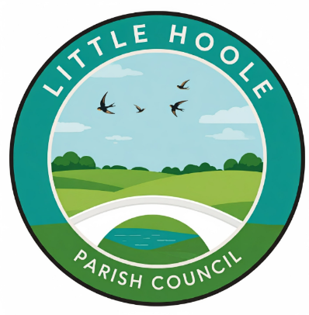
- Apologies for absence
- To agree the Minutes of the last Parish Council Meeting held on the 12th Jan 2026.
- To receive declarations of interest.
- Matters arising from the minutes of last meeting.
  - Public Time: to invite and listen to issues raised by members of the public.
  - To consider the following Planning Applications:
    - 07/2026/00128/HOH. 12 Great Gill Walmer Bridge PR4 5QP. Construction of dormer to front roof slope / west elevation
    - 07/2026/00120/HOH. 8 Rockburgh Crescent Walmer Bridge PR4 5RD. Erection of two storey side extension with front and rear dormers following removal of car port.
  - To approve the following transactions in the bank for Jan & Feb 2026.
  - Payments approved by email or pre-approved and retrospectively noted: Clerk’s claim for Jan 2026
  - Payments for approval Clerk’s claim for Feb 2026
  - To approve the Finance Statement as 28th Feb 2026.
  - Proposal for the Parish Council to approve the Clerk to undertake ILCA (Introduction to Local Council Administration) at a cost of £140 (excl VAT) plus approx. 10 hours study at approx. £180.
  - To review and approve the Grants & Donations Policy.
  - Update: re addition of signatory to the Parish Council’s Bank account.
  - Update: re the replacement of the two bus shelters at the junction of Liverpool Old Road and Liverpool New Road (Star Garage).
  - Update re Memory Bench
  - Update re tree carving on Dob Lane Recreation Park.
  - Update re PRoW 0707050, corner of A59 and Gill Lane.
  - To review the cost of moving SPiDs and consider alternative contractor.
  - Update re Insurance Claim.
  - Update re training for GDPR and Data Protection
  - Update re pedestrian access to Longton Health Centre & Longton Library
  - Update re Community Action Network
  - Discussion re Extension of Footpath on Dob Lane Recreation Park
  - Discussion re Purchase of 2 permanent SPIDs for existing posts.
  - Discussion re Dog Fouling
  - Summer Planting
  - To consider response to consultation on Local Government Reorganisation.
  - Information and Updates.
  - Correspondence – none
  - To agree the date, time, and venue for the April 2026 meeting.
Members of the public are welcome to attend meetings to raise any relevant matters. Alternatively, if you cannot attend the meeting but wish to raise a matter or ask a question, this can be done on your behalf by contacting the Parish Clerk (Paul Cafferkey) via email clerk@littlehoole-pc.gov.uk or mobile phone 07966267186.
Visit the Little Hoole Parish Council Website https://www.littlehoole-pc.gov.uk or scan the following QR code.



Prepared and approved by Paul Cafferkey, Clerk – Little Hoole Parish Council,
4th March 2026

